Protected: Sacred Arts Session 5: Sculpture and the Art of Simplicity
by uuwellspringdirector | Jul 1, 2021 | Curriculum: Sacred Arts | 0 comments
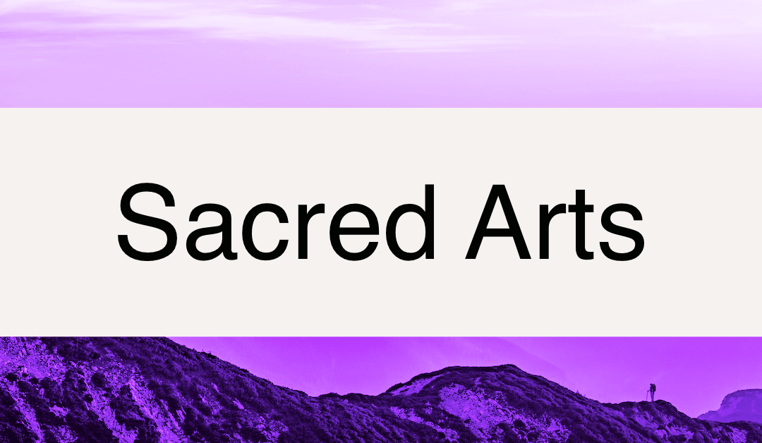

Email to Participants
Our next session is on [date]. We will be turning our attention to sculpture, a form that demands of the artist to make decisions of what is necessary and what is excess – and demands of observers of considerations of form and representation. Our readings and recordings will take us into the world of two female sculptors and to questions of simplicity and complexity.

Readings and Videos
- Spend some time exploring the art of Unitarian Universalist sculptor Kate Christopher .
- Learn about (19th century, female, West Indian/Chippewa) sculptor Edmonia Lewis. Note that a US stamp honors her impact on art.
- Read the sermon “The Wondrous Complexity of Simplicity“ by Rev. Joe Cleveland. Printed by the permission of the author.
- View this strong sculpture titled “Stepping Out” by Elizabeth Catlett.

Exercise
- Engage and encounter a sculpture – in person when possible, online when not. Remember to follow the process:
  - Observe in silence. Look with your heart, mind, body
  - Initial impressions. Note what you have observed.
  - Learning: learn about the art – who made it, when, why, the style/school, etc.
  - Sharing: reflect in your journal on the impact, meaning, and connections you are making with this piece of art.

Questions for Reflection
- In “The Wondrous Complexity of Simplicity,” Rev. Joe Cleveland suggests that by working through complexity there is a simplicity that lies on the other side. How might moving from complex to simpler decisions open your heart? What might be the downsides of keeping everything simple?
- Cleveland also raises a question about the relationship between simplicity and class; how do you see that manifesting in your life, your relationships, your congregation?
- Edmonia Lewis’ art transcends race, yet the focus during her lifetime in the 19th century was on the color of her skin. How do you experience focus on artists over their art?
- Elizabeth Catlett draws from both her African and her Mexican heritage. How do you connect with her work?

As a Reminder
Our shared observation during our last session was the Dancing House in Prague. Here are some links for more information:
- The full length version of the video
- The Wikipedia entry
I look forward to being with you!
In faith,

Session Plan

Gathering (5 minutes)
Note for Facilitators: Allow for some chatter, settling in, and other busy-ness; be gentle but firm as you call people in to listen to the reading and check in.
If you are meeting online: begin with everyone unmuted to allow for conversation before the Opening Words.

Chalice Lighting, Opening Reading, and Check In (25 minutes)
Our opening words are by (male) Brazilian novelist Paulo Coehlo:
The sculptor Michelangelo was once asked how it was that he could create such beautiful works. “It’s very simple,” he answered. “When I look at a block of marble, I see the sculpture inside it. All I have to do is remove what doesn’t belong.” The master says: “There is a work of art each of us was destined to create. That is the central point of our life, and — no matter how we try to deceive ourselves — we know how important it is to our happiness. Usually, that work of art is covered by years of fears, guilt and indecision. But, if we decide to remove those things that do not belong, if we have no doubt as to our capability, we are capable of going forward with the mission that is our destiny. That is the only way to live with honor.”
Listen to the song “Simple Faith“ by David Tamulevich.
If you are meeting online: Remember the setting adjustments for sharing video described in Session Two.
Also: Note that singing together on Zoom doesn’t work, so invite them to sing along with their mics muted.
Invite participants to sing along if they are comfortable; lyrics can be found here: http://evenpost.blogspot.com/2009/04/ours-is-simple-faith.html
Is there any deep concern you are carrying in your heart that we should know about?
What are you noticing about your spiritual practice? What is it revealing to you?
Share what’s happening in your work with your spiritual companion: What’s a recent insight? How are you applying new understandings? What question do you want to explore with them next?
Do you have anything to share from your creative work- either something you’ve observed or something you’re working on?

Covenant Review (2-5 minutes)
Note to Facilitators: Use the process your group has established to stay current with the covenant, including reading it out loud together at each session.
Is there anything about the covenant that we should address?

Shared Observation (20 minutes):
Note to Facilitators: If you have a sculpture that can be observed in your meeting room (or nearby), please show that piece and use Option One; you will need to do some research on your own. Do note: if it’s a piece that’s often spoken of in your congregation, you may wish to choose a different piece so that the observations are not loaded.
If you do not have a physical piece to bring in a sculpture, use Option Two – a photograph of a sculpture with information supplied.
If you are meeting online: Use Option Two – a photograph of a sculpture with information supplied.

Option One
Today, we’ll look at a sculpture and engage it with our four steps:
- Observe in silence. Look with your heart, mind, body. (3 minutes)
(show the sculpture – allow people to walk around and view it)
- Now, I invite your initial impressions: what did you observe? (5 minutes)
- Let me tell you about this piece.
(share the information you found)
- Now, I invite your reflections on the impact, meaning, and connections you are making. Would anyone like to share a thought or two? (10 minutes)

Option Two
Today, we’ll look at a photograph of a sculpture and engage it with our four steps:
- Observe in silence. Look with your heart, mind, body. (3 minutes)
(show this image)
- Now, I invite your initial impressions: what did you observe? (5 minutes)
- Let me tell you about this piece:
  - This sculpture is called “Expansion” and was created by Paige Bradley, an American sculptor known for representative figurative bronzes. She is a classically trained American sculptor living and working in London, England. In 2001 Bradley was voted into the National Sculpture Society as a professional sculptor. She has created pieces for the Ballet International Foundation in Pittsburgh, the St. Cloud (MN) Hospital, and the Royal Bromton Hospital in London.
  - Bradley says of this piece (in https://mymodernmet.com/riveting-story-behind-that/):
“…literally, I took a perfectly good wax sculpture – a piece I had sculpted with precision over several months – an image of a woman meditating in the lotus position, and just dropped it on the floor. I destroyed what I made. I was letting it all go. It was scary. It shattered into so many pieces. My first feeling was, ‘What have I done!?!’ Then, I trusted it would all come together like I envisioned.
“We cast all the pieces in bronze and assembled the pieces so they floated apart from one another. Then I brought in a lighting specialist and we built a crazy lighting system to make it glow from within. It turned out even better than I thought. And the best is that the image of Expansion means so much to so many who see it. I get letters every day! I feel like I really did my job successfully!”
https://mymodernmet.com/riveting-story-behind-that/
Now, I invite your reflections on the impact, meaning, and connections you are making. Would anyone like to share a thought or two? (10 minutes)

Reflections (50 minutes):
Note to Facilitators: Invite participants to choose the prework observation, reading, or reflection question that most intrigued them. Note that you may not get to many of the questions, depending on the direction your conversation goes. Do remind them, as needed, that participants often reflect that the readings inform their observations and experiences but don’t necessarily lead them into deeper discussion; often, they set the stage for the individual and shared observations or their own creativity.
- In the prework, you were asked to observe some sculpture. What piece caught your attention? What did you observe? How do you connect with this sculpture?
- How do you connect with this art form? Are you a practitioner, spectator, first timer? How does that affect your approach to this art?
- What lessons might this form teach you?
- In “The Wondrous Complexity of Simplicity,” Rev. Joe Cleveland suggests that by working through complexity there is a simplicity that lies on the other side. How might moving from complex to simpler decisions open your heart? What might be the downsides of keeping everything simple?
- Cleveland also raises a question about the relationship between simplicity and class; how do you see that manifesting in your life, your relationships, your congregation?
- David Tamulevich’s song says “ours is a simple faith.” Is it? What might have been “taken away” in order to be a simple faith?
- Edmonia Lewis’ art transcends race, yet the focus during her lifetime in the 19th century was on the color of her skin. How do you experience focus on artists over their art?
- Elizabeth Catlett draws from both her African and her Mexican heritage. How do you connect with her work?

So What? (10 minutes)
How does this reflection relate to your spiritual journey? Your creative work? What are you inspired or challenged to do next?

Gratitude and Closing (5 minutes)
As you prepare to pack up and clean up, each person, as moved, says one or two words about something from this session for which they are grateful or how they are feeling in this moment. After everyone has said a word, close with a brief statement of thanks and appreciation, and clean up art supplies as needed.
If you are meeting online: Encourage everyone to focus on the chalice and unmute to share their gratitude.

