Proposed Article II

Article II of the Unitarian Universalist Association (UUA) Bylaws, Principles and Purposes, is the foundation for all the work of our UUA and its member congregations and covenanted communities. It is the covenant to which Unitarian Universalist congregations and covenanted communities pledge themselves when they become members of our UUA.
This four-session program will allow you to engage with all of Article II to better understand and embrace it.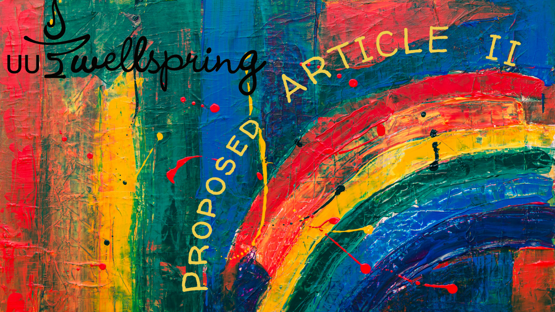
Four sessions, 90 min each, provide a deep dive into the Article II proposed by the UUA. UU Wellspring is offering three online programs (open to any UUs) or congregations can also purchase it to hold as many groups as they like at times that are convenient in their own congregation.

Goal:
Our goal is to have Unitarian Universalists take a deeper dive while in a covenanted community before reacting to or giving feedback on the proposed Article II. GA delegates will especially appreciate the exploration, but all are welcome.

Facilitators:
Anyone with good facilitation skills can facilitate the program in your UU congregation or organization. No experience with UU Wellspring is necessary as the online guide is user friendly and provides a step-by-step guide to facilitation.

Our online programs are facilitated by very experienced UU Wellspring leader.

Cost:
$150 for a congregation to hold as many cohorts as they like in 2023.
$100 per individual enrolling in an online program.

Sessions:
1: Covenant
Use the covenant section from the Proposed Article II to explore and live into.

2: Purpose, Inspirations, Inclusion and Freedom of Belief
Focus on the sections before and after the values and covenant.

3. Love
Explore the centering value in the proposed Article II.

4. Six Values: Interdependence, Justice, Equity, Generosity, Pluralism, and Transformation
Connect with the values and their meaning in our lives and communities.

Enroll here for either online or congregational programs.

