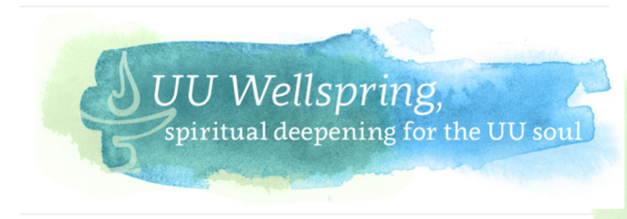
UU Wellspring: Spiritual Ancestors
There is a Senegalese proverb that says, “The future emerges from the past.”
As Unitarian Universalists, we are constantly looking to the future, to build a new way, to bend the moral arc of the universe toward justice, to build the beloved community. But to do this work, we must know our past – our collective histories as well as our personal histories. Who calls to us from our pasts and our present? Who calls us toward our future? And how do we reconcile the difficult legacies as we try to heal ourselves and our world?
These are some of the questions we will engage in Spiritual Ancestors. Yes, they are deep, and sometimes fraught. Thus, the sessions will ground us further into deep listening, storytelling, and courageous space-making. The sessions will require your attention as we hold one another in a covenantal, anti-racist/anti-oppressive, courageous space.
The sessions will also enlighten and delight as we learn more about the experiences and influences of our fellow travelers on this journey; some may discover new

Structure
We begin this journey together with an examination of our own spiritual timelines and how we tell the stories of our lives and those who have influenced us.
Having set the groundwork for our journeys, we then move on to engage Unitarian and Universalist ancestors whose stories inform our current faith. From there we explore other ancestors from the worlds of art, justice, science, literature, philosophy, and spirituality. We also wrestle with those ancestors whose stories are more concerning. We pause at the end of October/beginning of November for an All Souls ritual to honor our ancestors, and also pause in December to celebrate the ancestors and traditions of the many December holidays/holy days. We return to our own faith as we examine the ancestors of modern Unitarian Universalism, then wrap up the program with an examination of what it means to be a good ancestor and celebrate our journey with a closing ritual.
After the first few sessions, there will be little, if any, readings or videos for pre-work. Instead, the pre-work will be self-directed research as they explore their own ancestors and the subsequent reflection questions. We know that many UU Wellspring participants will do the readings but not the questions; please encourage everyone to do the deeper reflective work, as it is in reflection that the learning, strengthening, and healing will happen.
You will also note that the “So What” questions are different from other UU Wellspring programs; while our work in the world is always a focus, Spiritual Ancestors has a slightly more inward focus. In Session 2, participants will be asked to create a personal spiritual timeline; our “so what” question will continue to draw focus to those timelines, inviting participants to build their individual clouds of witnesses. The sessions will also enlighten and delight as we learn more about the experiences and influences of our fellow travelers on this journey; some may discover new ancestors of inspiration or be reminded of some who have been meaningful to us. We will also discover what qualities inspire our own and others' journeys.

Topics
Session 1 — Retreat
Session 2 — Storytelling
Session 3 — Unitarian Ancestors
Session 4 — Universalist Ancestors
Session 5 — Honoring the Dead
Session 6 — Owning our Scoundrels
Session 7 — December Ancestors
Session 8 — Artistic Ancestors
Session 9 — Justice Ancestors
Session 10 — Scientific Ancestors
Session 11 — Literary Ancestors
Session 12 — Philosophical and Spiritual Ancestors
Session 13 — Modern Unitarian Universalist Ancestors
Session 14 — Being a Good Ancestor
Session 15 — Closing Celebration

Required book: Heartwood: The Art of Living with the End in Mind by Barbara Becker

