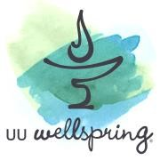
UU Wellspring: Deep Questions
Revised March 2021
Background
UU Wellspring has been designed as a Unitarian Universalist spiritual deepening program, drawing on the broad resources of UU history and theology to help each of us find our own unique answers to the deep questions of our lives. In this program, we examine the seven Unitarian Universalist principles through the lens of our own experience and beliefs, to see what meaning those principles may have in our lives. We also dive deeply into some of the powerful questions of our lives. Some of these questions we touched on in the first-year Wellspring program, such as human nature and forgiveness, and some are unique to this program, such as accountability and our relationship to the planet.
In every session, we confront the hard questions about how these principles and our own beliefs affect our actions in the world. We know that one of the goals of the spiritual life is to bring our actions in line with our values and beliefs, and this program encourages us to articulate those values and beliefs for ourselves. We believe that spiritual practice helps us open our hearts and minds both to deeper truths that may become evident to us, as well as helping us find greater compassion and love for our companions in the search for truth and meaning as we hear their stories and their beliefs.
Structure
The Deep Questions program alternates between sessions on the seven UU principles (and the proposed Eighth Principle) and sessions on the deep questions of our lives, offering a total of nineteen sessions. The homework for each session includes pre-work - usually at least one reading, plus a chapter from one of the books, Welcoming the Unwelcome by Pema Chödrön or The Seven Principles in Word and Worship, edited by Ellen Brandenburg.
Often there is an activity—and there is time in the session for reflection on the pre-work and the questions raised in each session. Each session includes more suggestions for reflection than can be managed in any one session, but because participants (and facilitators) are UU Wellspring veterans, the expectation is that they will choose which questions to focus on, based on the content and reflections that arise in previous sessions and on their own needs and experiences.

UU Wellspring: Deep Questions Topics

Session One:
Reconnecting and Opening Ritual
Session Two:
The inherent dignity and worth of every person
Session Three:
Human Nature
Session Four:
Justice, equity and compassion in human relations
Session Five:
Forgiveness
Session Six:
New Year’s Ritual
Session Seven:
Acceptance of One Another…
Session Eight: Prayer
Session Nine:
Free and Responsible Search for Truth and Meaning Session Ten: Death and Dying
Session Eleven:
The Right of Conscience ...

Session Twelve: Accountability
Session Thirteen: World Community
Session Fourteen: Sacred Activism
Session Fifteen:
The Interdependent Web
Session Sixteen:
Our Relationship to Ecology and the Planet
Session Seventeen: Eighth Principle (optional)
Session Eighteen:
Closing and Farewell

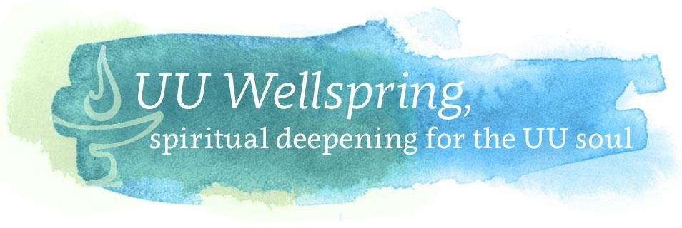
Books for Deep Questions
There are two primary books for this program:
- The Seven Principles in Word and Worship, edited by Ellen Brandenburg (available through UUA Bookstore and other online sellers)
- Welcoming the Unwelcome, by Pema Chodron.
Several optional books:
- Becoming: A Spiritual Guide for Navigating Adulthood edited by Kayla Parker (links needed are all available and provided)
- With Purpose and Principle: Essays about the Seven Principles of Unitarian Universalism, edited by Edward A. Frost.
- After the Good News: Progressive Faith Beyond Optimism by Rev. Nancy McDonald Ladd.

